43.56: The -particle will have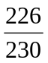 of the mass energy (see Example 45.5)
